**Module 3: Critical Thinking**

Mohammad Sargazi

Colorado State University Global

CSC450: Programming III

Dr. Haseltine

Nov 10, 2024

1. **Pseudocode**
2. BEGIN PROGRAM
3. DECLARE VARIABLES:

value1 as INTEGER

value2 as INTEGER

value3 as INTEGER

ptr1 as POINTER to INTEGER

ptr2 as POINTER to INTEGER

ptr3 as POINTER to INTEGER

1. PROMPT USER to "Enter the first integer:"

STORE INPUT in value1

1. PROMPT USER to "Enter the second integer:"

STORE INPUT in value2

1. PROMPT USER to "Enter the third integer:"

STORE INPUT in value3

1. ALLOCATE DYNAMIC MEMORY **for** each pointer:

ptr1 = **new** INTEGER

ptr2 = **new** INTEGER

ptr3 = **new** INTEGER

1. STORE VALUES IN POINTER LOCATIONS:

Set *ptr1 to value1

Set *ptr2 to value2

Set *ptr3 to value3

1. DISPLAY OUTPUT:

Show "Values entered:"

Show "Value1: " + value1 + ", Pointer1: " + *ptr1

Show "Value2: " + value2 + ", Pointer2: " + `*ptr2

2**- Source code:**

//============================================================================

// Name : Pointer.cpp

// Author : MS

// Version :

// Copyright : Your copyright notice

// Description : Hello World in C++, Ansi-style

//============================================================================

**#include** <iostream> // Include library for input and output

**using** **namespace** std;

**int** **main**() {

// Variable declarations to store user input

**int** value1, value2, value3;

// Ask the user to enter three integer values

cout << "Enter the first integer: ";

cin >> value1;

cout << "Enter the second integer: ";

cin >> value2;

cout << "Enter the third integer: ";

cin >> value3;

// Creating integer pointers and allocating dynamic memory for each variable

**int**\* ptr1 = **new** **int**; // Pointer for the first value

**int**\* ptr2 = **new** **int**; // Pointer for the second value

**int**\* ptr3 = **new** **int**; // Pointer for the third value

// Storing the values in the dynamically allocated memory

*ptr1 = value1;

*ptr2 = value2;

*ptr3 = value3;

// Display the contents of the variables

cout << "\nValues entered:" << **endl**;

cout << "Value1: " << value1 << ", Pointer1: " << *ptr1 << **endl**;

cout << "Value2: " << value2 << ", Pointer2: " << *ptr2 << **endl**;

cout << "Value3: " << value3 << ", Pointer3: " << *ptr3 << **endl**;

// Free the dynamically allocated memory using the delete operator

**delete** ptr1;

**delete** ptr2;

**delete** ptr3;

// Set pointers to null after deletion (good practice)

ptr1 = **nullptr**;

ptr2 = **nullptr**;

ptr3 = **nullptr**;

**return** 0; // End of the program

}

3- **Screenshot**

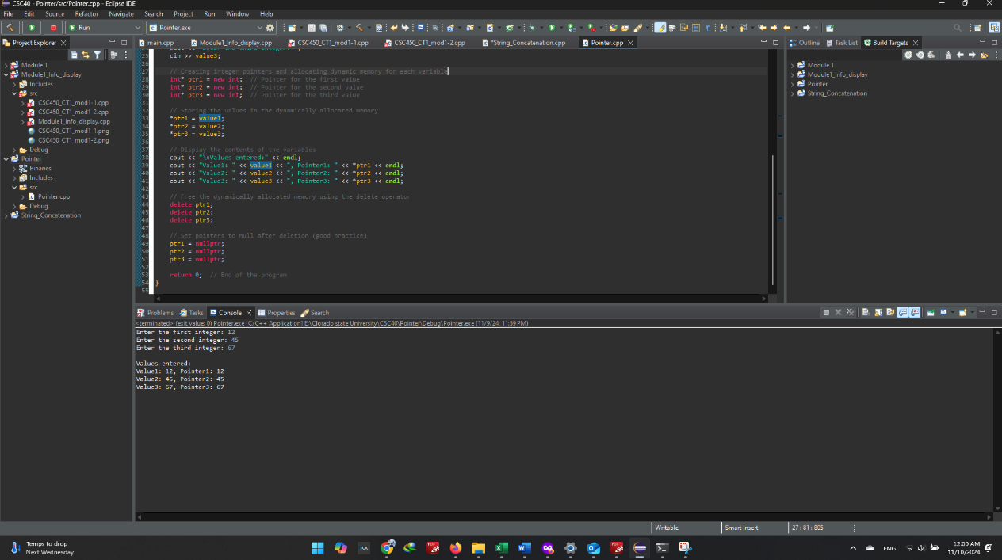

**4- GitHub Screenshot**

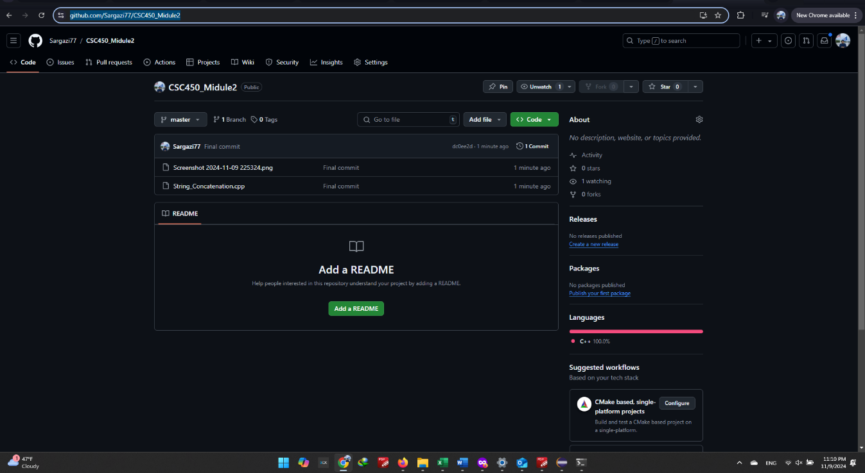

**6- GitHub link:**

[**https://github.com/Sargazi77/CSC450_module3**](https://github.com/Sargazi77/CSC450_module3)